Step 1; open a below url

<https://www.google.com/search?q=node+js+download+for+windows+11&rlz=1C1VDKB_enIN1075IN1075&oq=node+js+download+for+windows+11+&gs_lcrp=EgZjaHJvbWUyDAgAEEUYORiABBiiBDIHCAEQABiABDIICAIQABgWGB4yCAgDEAAYFhgeMggIBBAAGBYYHjINCAUQABiGAxiABBiKBTINCAYQABiGAxiABBiKBTIKCAcQABiABBiiBNIBCDU2NzFqMGo3qAIAsAIA&sourceid=chrome&ie=UTF-8>

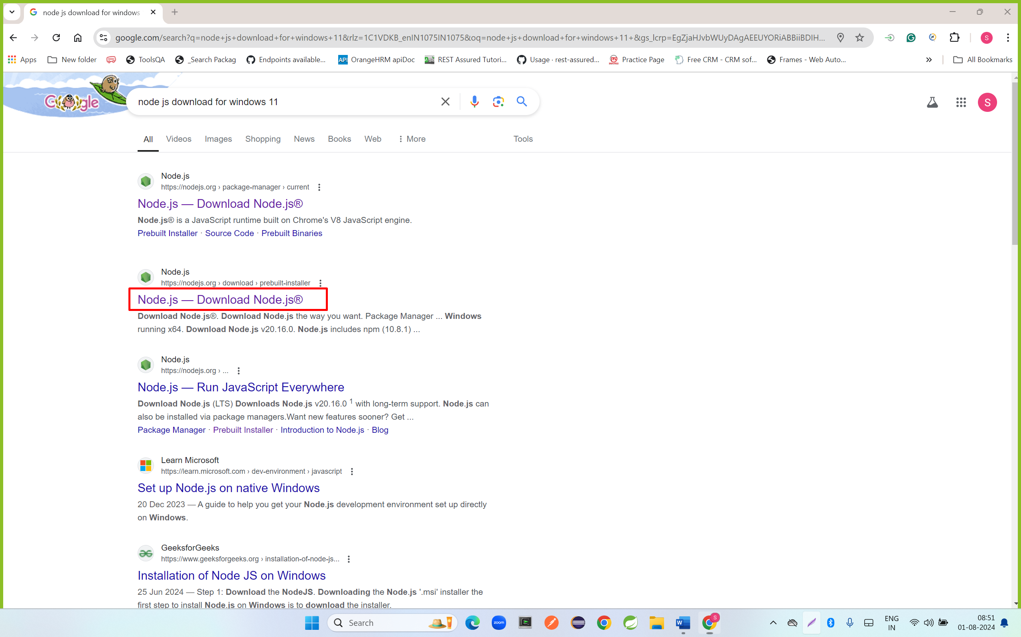

Step 2:

<https://nodejs.org/en/download/prebuilt-installer>

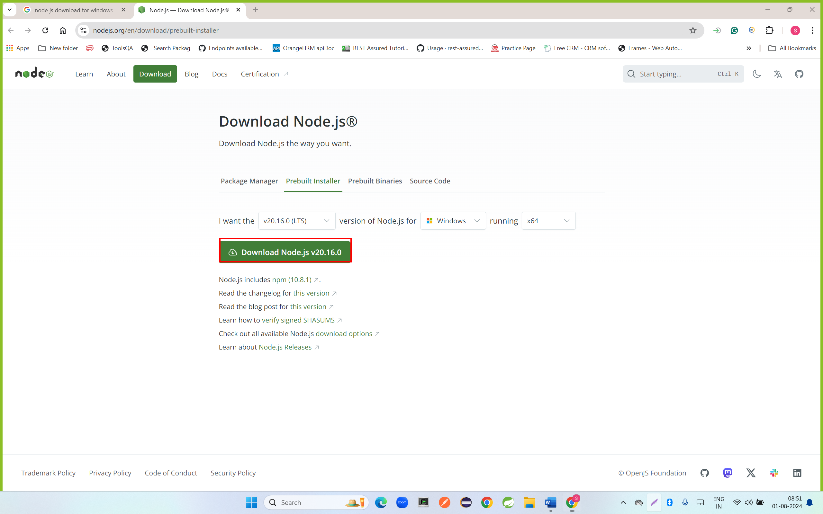

Step 3: go to download folder and double click on downloaded file

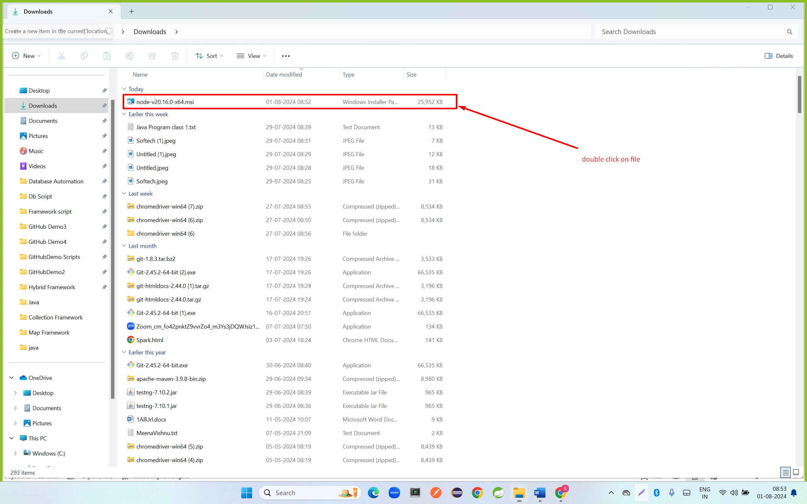

Step 4: click on next button

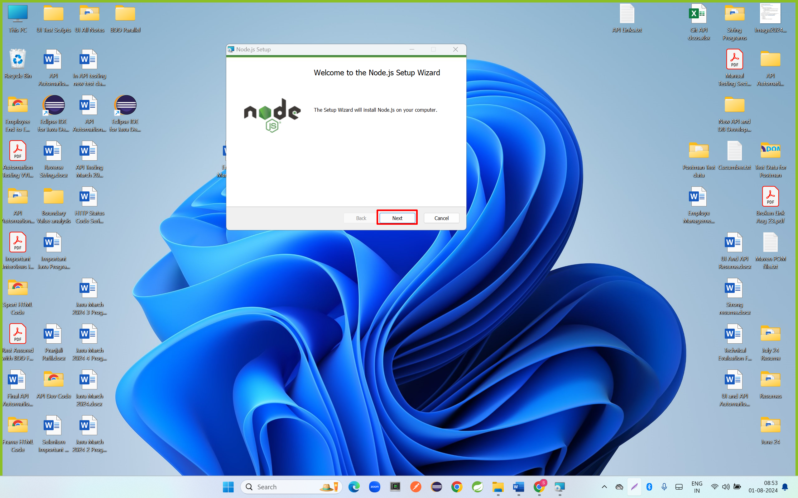

Step 5: click on checkbox and click on next button

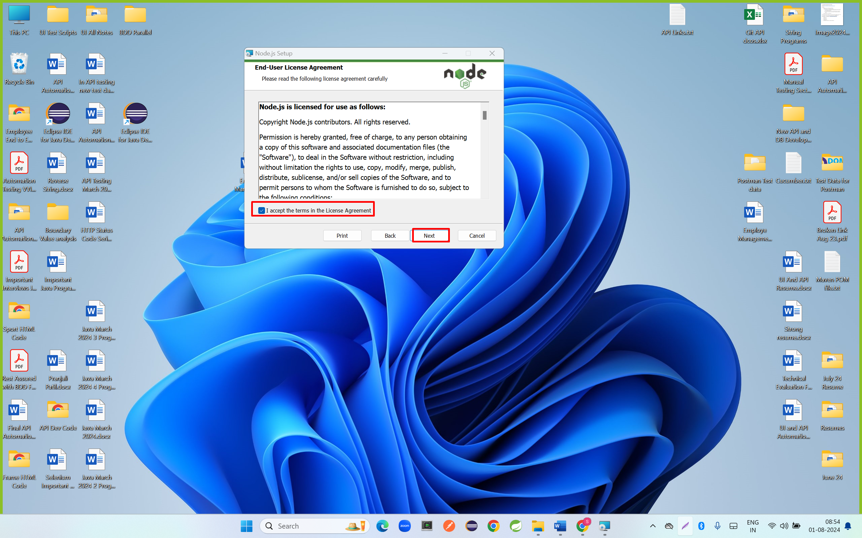

Step 6: click on next button

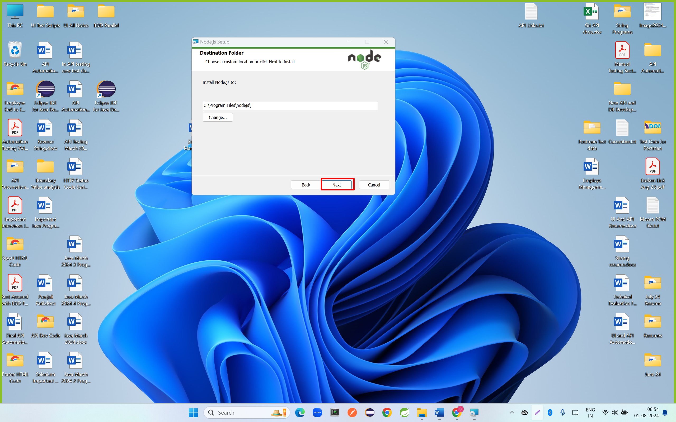

Step 7: click on next button

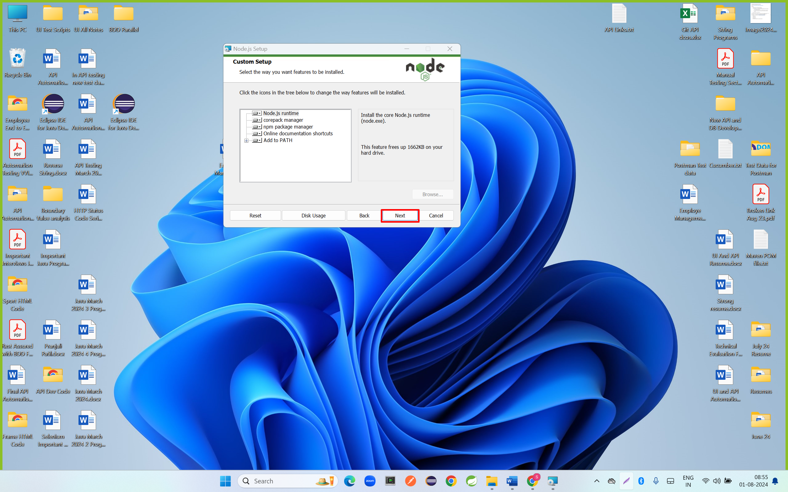

Step 8: click on next button

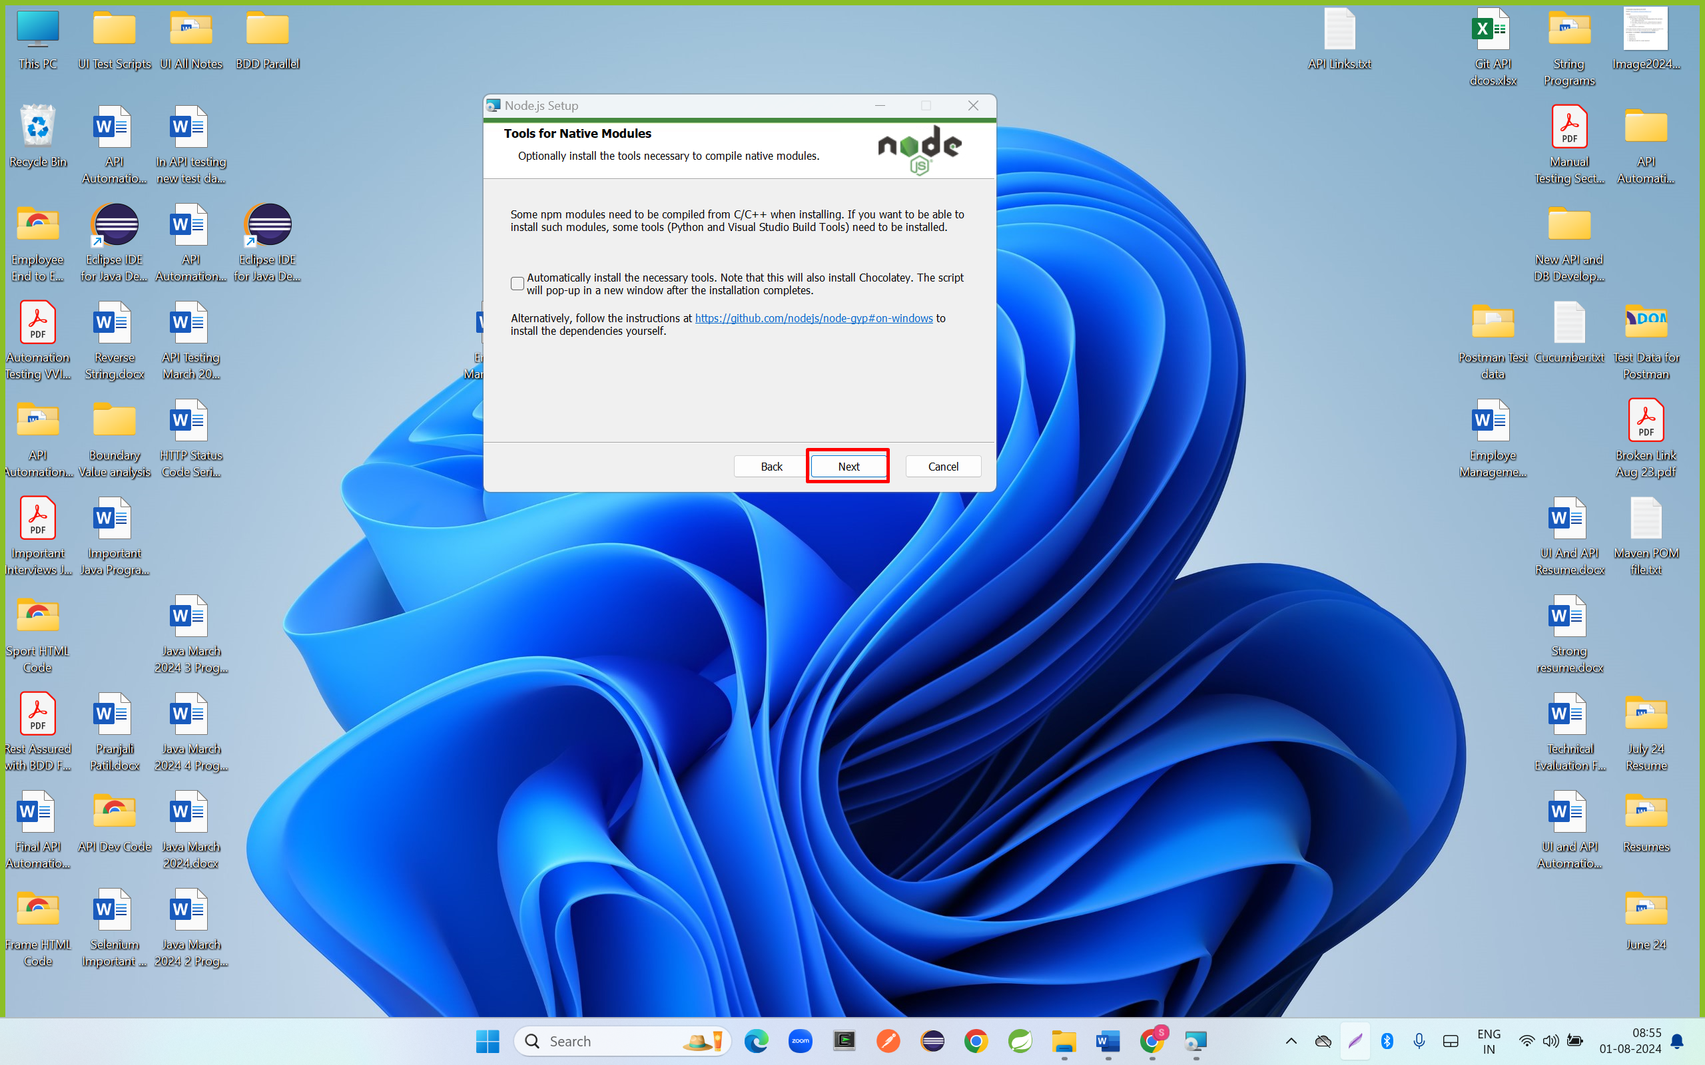

Step 9: click on install button

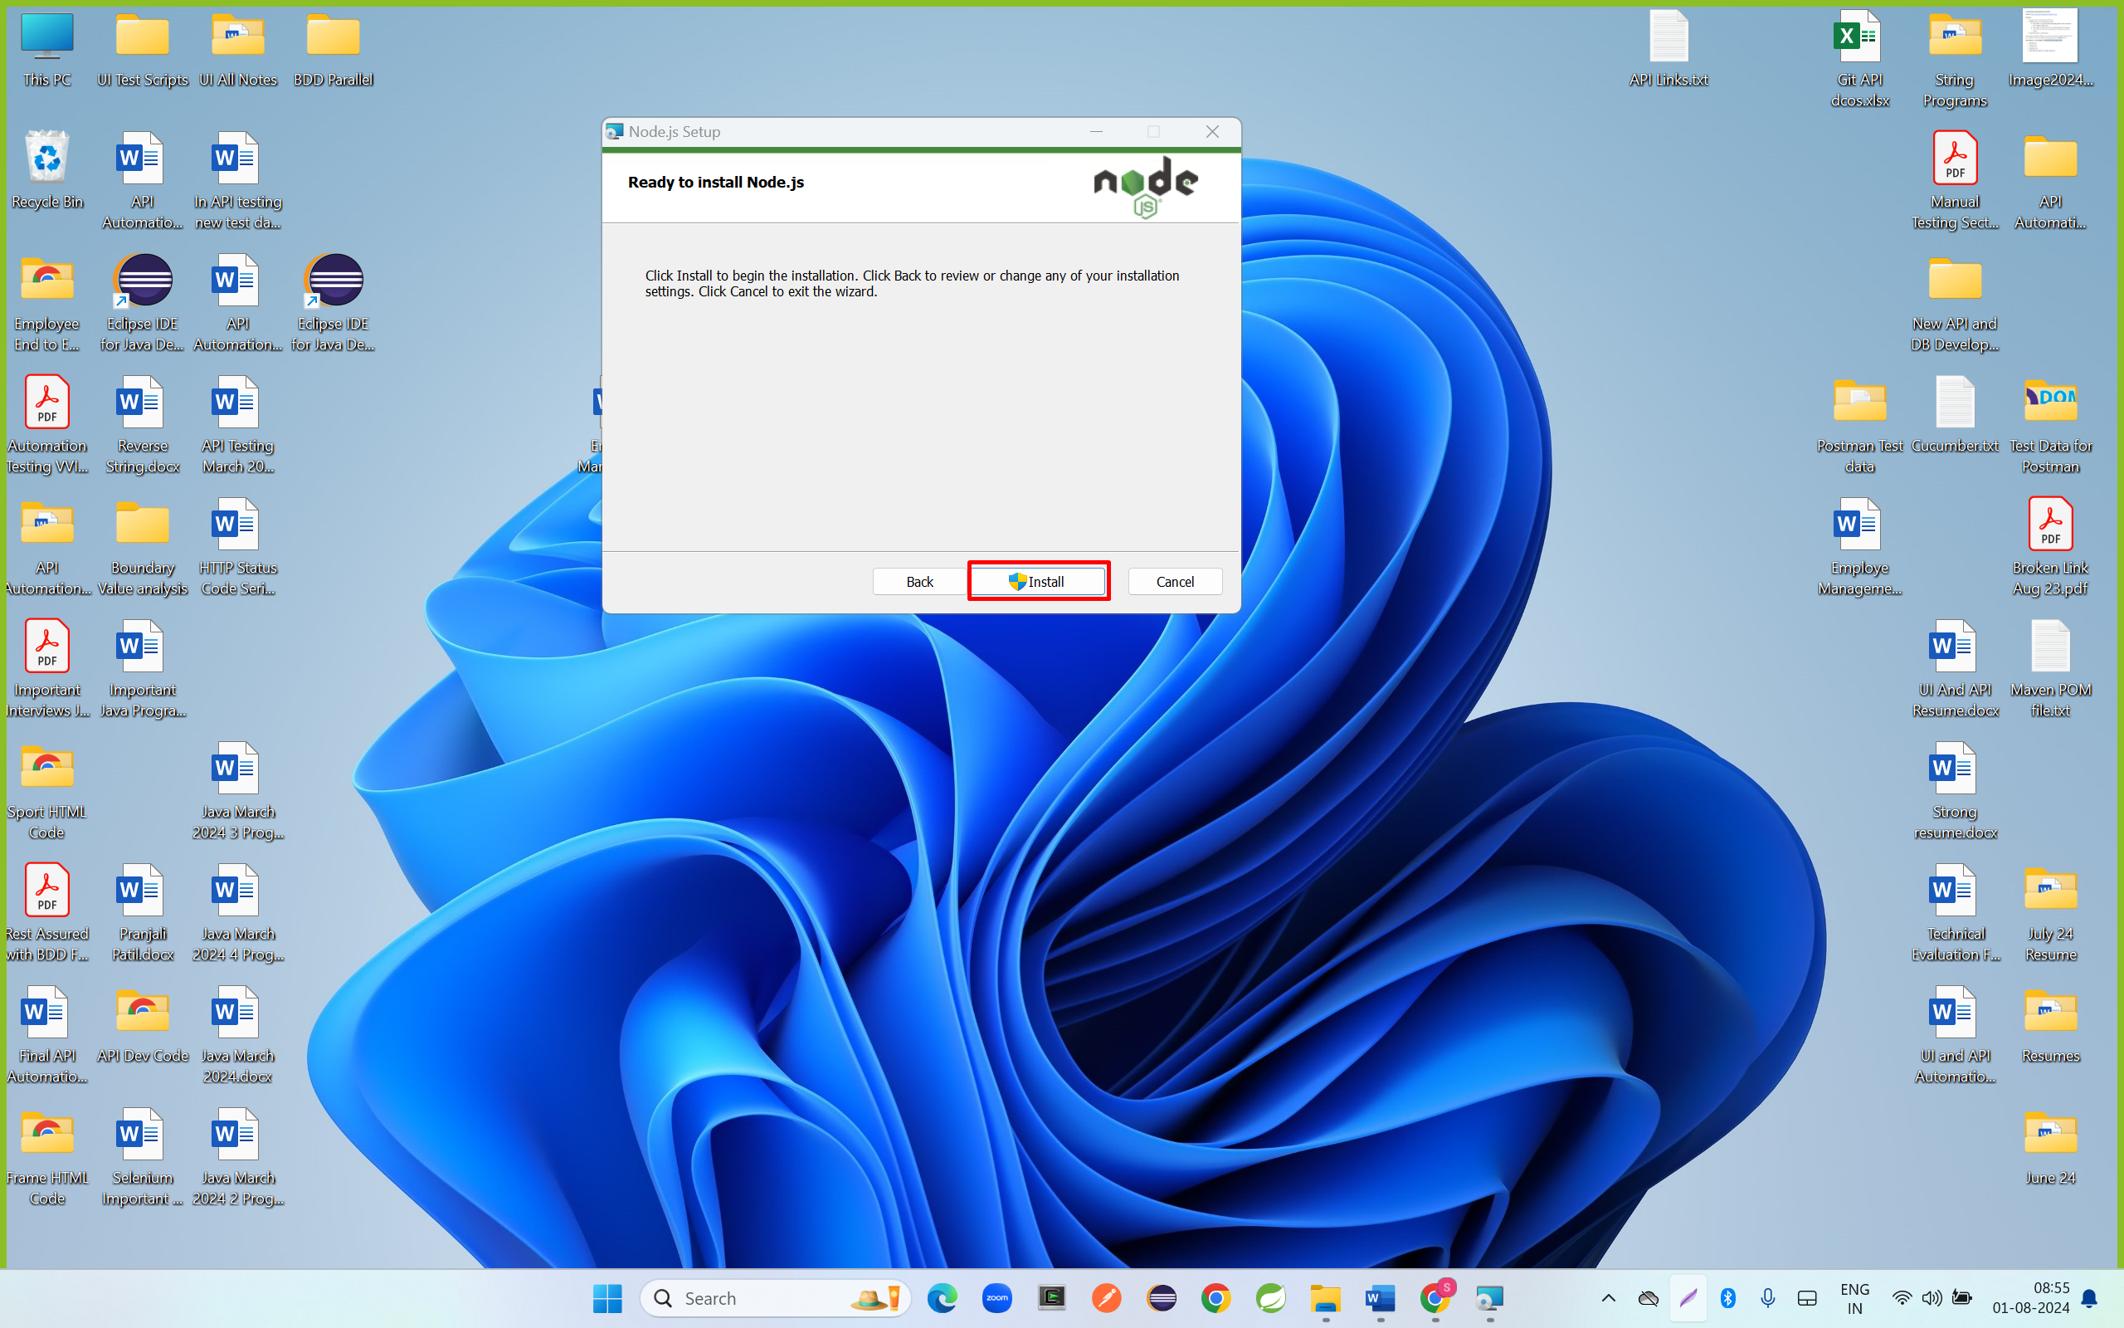

Step 10: click on finish button

